***FAKE NEWS DETECTION USING NLP***

***TEAM MEMBER***

***731721106013- A.POONGOTHAI***

***PHASE-2 PROJECT SUBMISSION***

***PROJECT: Fake News Detection***



***INTRODUCTION:***

* ***Fake news detection is a critical task in today's information age. It involves the identification and verification of misleading or fabricated information presented as factual news.***
* ***With the proliferation of social media and digital platforms, the spread of fake news has become a significant concern, impacting public discourse and decision-making.***
* ***In this context, advanced technologies, such as natural language processing and machine learning, play a vital role in developing tools and algorithms to detect and combat fake news effectively.***
* ***This is a challenging and evolving field that aims to safeguard the integrity of information and promote responsible journalism in the digital era***

***CONTENT FOR PROJECT PHASE-2:***

***Consider the Utilizing advanced algorithms and data analysis to identify misinformation and disinformation in digital content.***

***DATA SOURCE:***

***Employing robust methodologies to assess the credibility and authenticity of information providers to enhance the accuracy of news verification processes.***

***DATA INFORMATIONS:*** [***https://colab.research.google.com/drive/17F0tNEh1Rugi_CqmxBzqHw4AJjE5TYyI?usp=sharing***](https://colab.research.google.com/drive/17F0tNEh1Rugi_CqmxBzqHw4AJjE5TYyI?usp=sharing)

***SOURCE CODE:***

%pip install transformers datasets --quiet

*# Imports for Dataset*

importtime

importnumpyasnp

importpandasaspd

importnltk

importstring

importtensorflowastf

fromnltk.corpusimportstopwords

fromsklearn.model_selectionimporttrain_test_split

nltk.download('stopwords')

*# Data Visualization*

importplotly.expressaspx

*# Classification Model*

fromtransformersimportAutoTokenizer,TFAutoModelForSequenceClassification

*# Model Training*

fromtensorflow.keras.optimizersimportAdam

fromtensorflow.keras.callbacksimportModelCheckpoint

*# Data set management*

CLASS_NAMES=["Fake","Real"]

MAPPING_DICT={

"Fake":0,

"Real":1

}

*# Model Callbacks*

model_name="BERTFakeNewsDetector"

MODEL_CALLBACKS=[ModelCheckpoint(model_name,save_best_only=True)]

fake_news_filepath="/kaggle/input/fake-and-real-news-dataset/Fake.csv"

real_news_filepath="/kaggle/input/fake-and-real-news-dataset/True.csv"

In [5]:

fake_df=pd.read_csv(fake_news_filepath)

real_df=pd.read_csv(real_news_filepath)

In [6]:

linkcode

fake_df.head()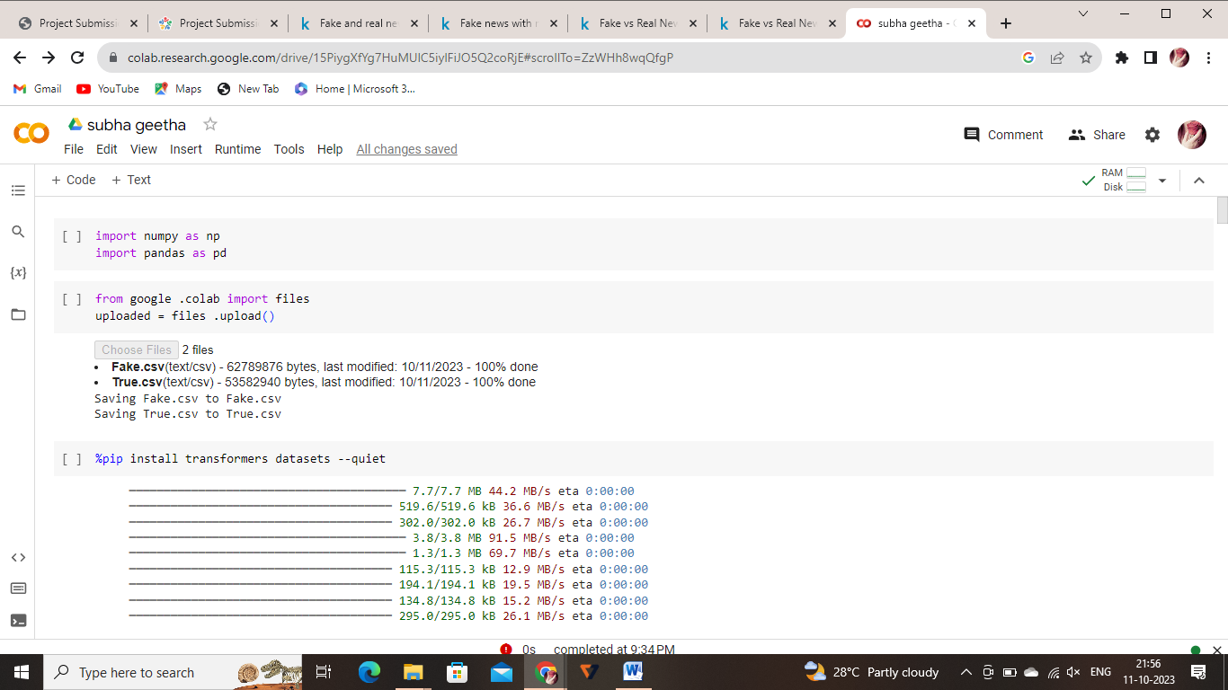

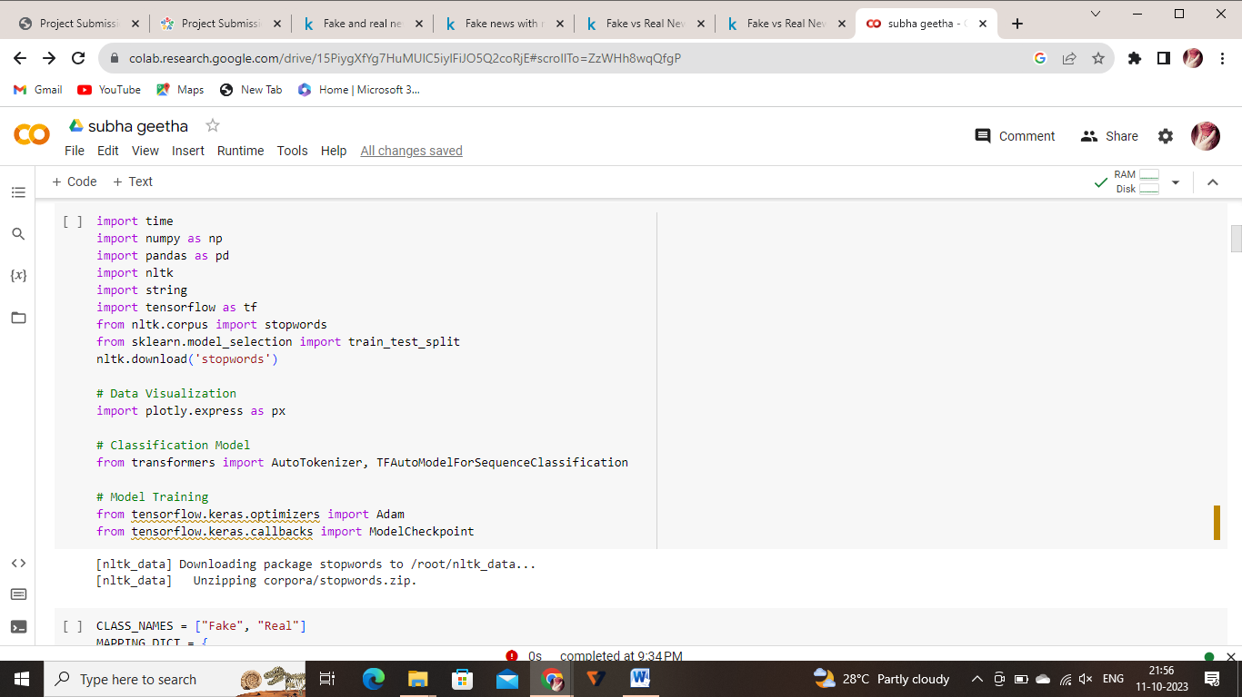

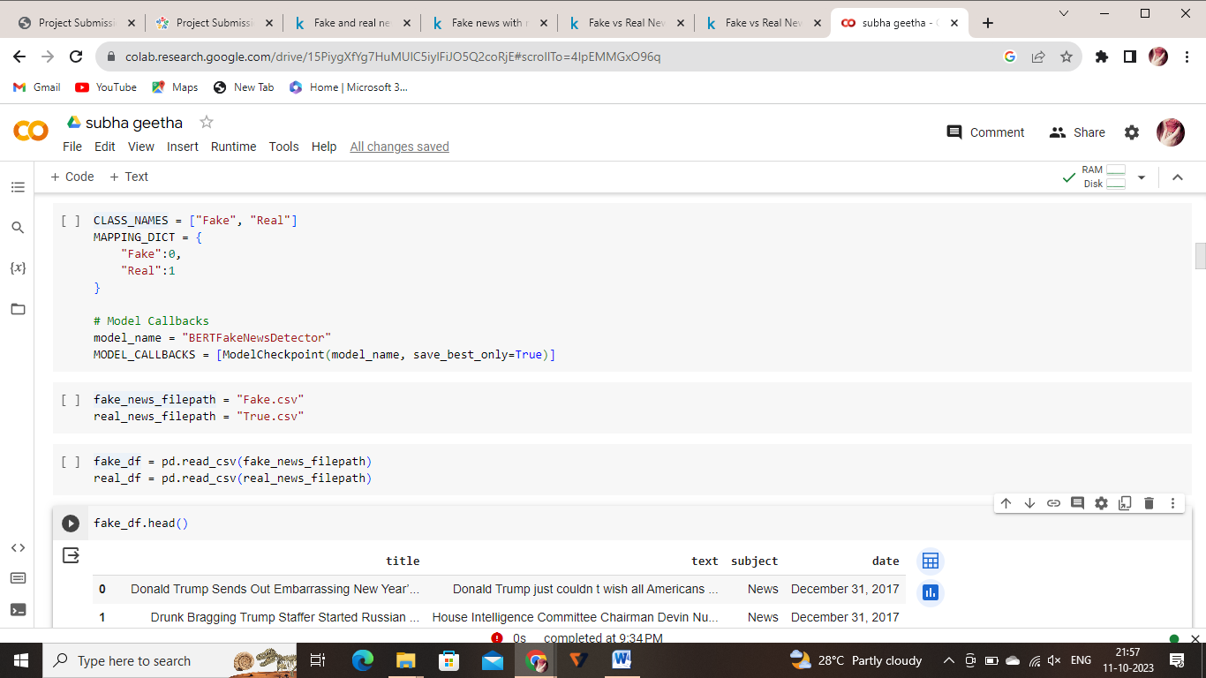

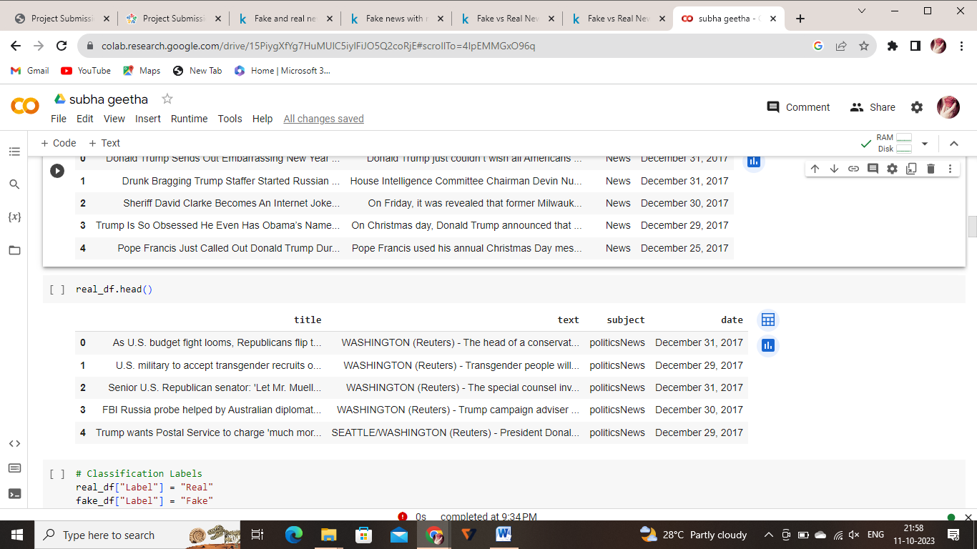

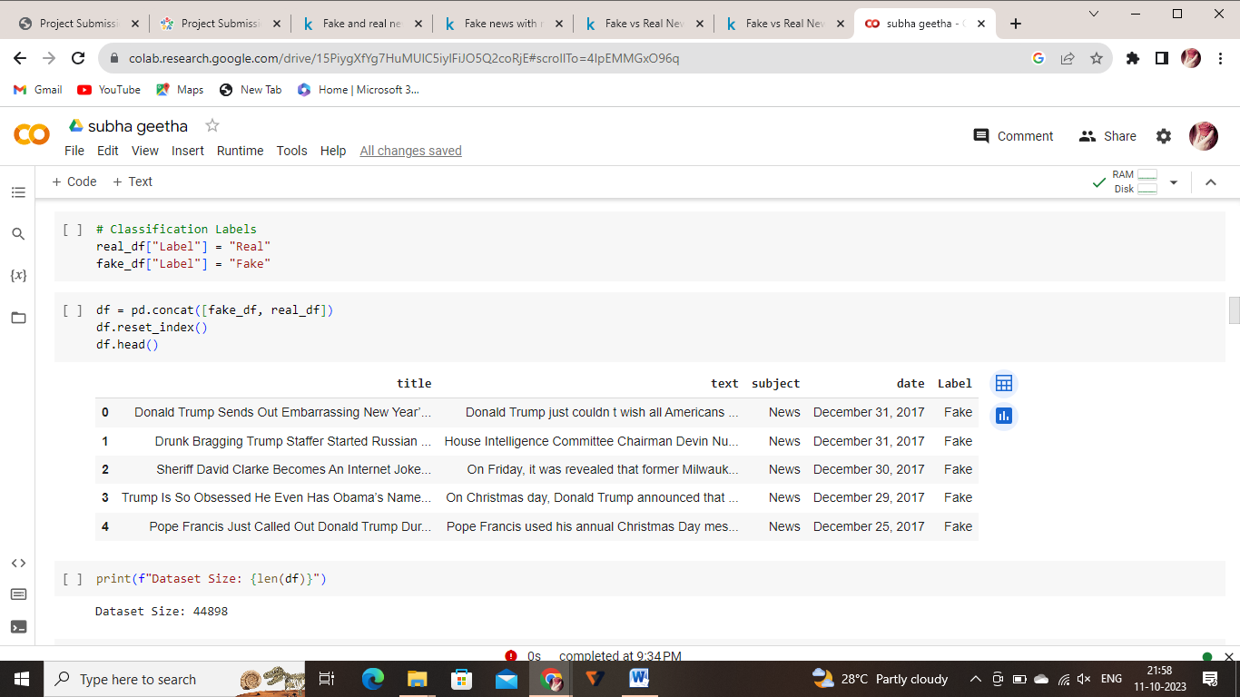

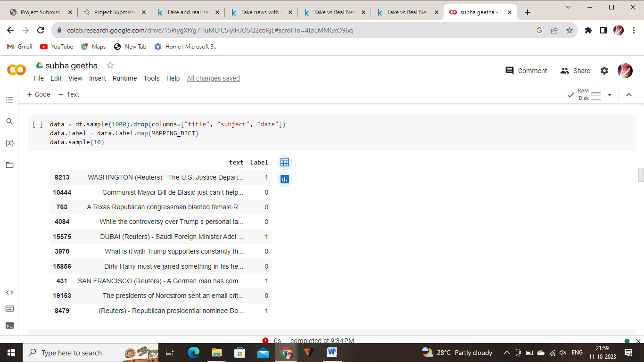

***DATASET LINK:***

[**https://www.kaggle.com/datasets/clmentbisaillon/fake-and-real-news-dataset**](https://www.kaggle.com/datasets/clmentbisaillon/fake-and-real-news-dataset)

***That’s all the informations we gathered…!***